**Abstract**

Researchers have long tried to estalish causal association between climate change and social conflict. Even though there is no general consensus on a direct causal relationship, a lot of studies have shown various causal pathways from climate variability towards civil conflict and dynastic change. Social harmony largely depends on economic growth collective dependency on agricultural production

Climate change affects socio dynamics through agro-ecological and geo-political The correlation and causal relationship between climate change and has been studied vigorously as we can get deep insight about global climate change and its impact on our modern times from the past.

Historical events across the regions for last 2000 years seem to have correlation with climate change. The global temperature data has been shown to have influence over the dynastic change in the history of human civilization. The sun has been shown to be a climate driver in different experiments. The fourier spectrum of our event data shows the strongest components as 405 yr, 150 yr, 101 yr.

The combined global temperature from different proxies have shown the strongest component as ~1000 yr, ~460 yr, and ~190 yr periods. This shows some lag with the cultural event cycle our analysis has shown.

Fourier spectral analysis has shown cyclicity or periodicity in nature in different scientific studies. The sun and the earth are dissipative system with energy input. When the energy input into a dissipative system is increased beyond the range of static stability.

Periodic or cyclic behavior is so common in nature and physics that it gives the analysis technique of Fourier transform its outstanding importance. The reason for the abundance of cycles lies in the property of the transition from static to dynamic behavior. This “modulational instability” occurs in space and time when the energy input into a dissipative system is increased beyond the range of static stability. It leads overwhelmingly to a periodic state (rare exceptions exist, e.g. the Lorenz model, where the onset of dynamics is chaotic). The Sun and the Earth are classic dissipative systems with energy input. Cyclic dynamics is therefore to be expected. Cycles with periods ranging from several

Urbanization leads to a profound transformation of the countryside and, hence, to a shift in local climate. The construction of buildings, paving of streets, sealing of areas and reduction of vegetation are important aspects. Among other consequences, these changes result in decreasing wind speeds, less evapotranspiration, and increasing uptakes of solar radiation. All of the mentioned factors cause a rise in temperatures compared to the rural surroundings of a city, generating the so called Urban Heat Island (UHI)

he Little Ice Age occurred just after the Medieval Warming Period extending from the 16th to the 19th century and caused a great deal of problems for life at the time. It mainly occurred in Europe and North America and it caused colder winters increasing starvation and causing famine. Many people died of the cold as the couldn't adapt and many people struggled to find food and crops failed as they weren't suitable or adapted to the environment of the Little Ice Age.

Slowly, the people living in the Little Ice Age learnt to adapt to the environment. Farmers changed their crops so people started to find food again and so lives of the people living in the Little Ice Ag improved and they started to make use of the cold weather and used it for entertainment. Frost fairs were set up when rivers froze over and the River Themes  was often a host for frost fairs where stalls and games were set up on the ice and music was played so people had entertainment and some people made money from what people bought while they were there.

But the Little Ice Age didn't just effect the people living there at the time, it affected the animals and plants too. They weren't used to the climat either and so also struggled to adapt

**Results and discussions**

**Causal Model**

Climate change causes the changes in human activities by displacing people from one region to another. Several studies have tried to build model between the connection between climate change and migration. We know that

The history of agricultural activities is very old. Since the beginning of time, human beings were involved in producing diverse range of crops based on the nature of the productivity in the soil of that regions. We have literally transformed the surface of the planet for our own use by making farmlands. Studies show that 12% of our land surface is used for cultivation and another 22% is used for pastures and rangelands (Billie et al 2014 – Geographic distribution of major crops). Global distribution of crops show our dependency on cereals, tubers, sugar crops, pulses, oil-bearing crops, fiber crops. Agricultural industry over time had to maintain a strong network of production and transportation of the crops. It’s very easy to see how the crop production and transportation can be disturbed by major natural calamities. Temperature proxies can be a good indicator to show the climate change throughout the human history. Historical data of Northern hemisphere tree ring and grain yield and agricultural index have shown the disturbance of bio-productivity due to climate change. Changes in bio-productivity affect the food supply per capita which is reflected in grain price and wage index. The unavailability in the supply of food can cause famine which may consequently cause social unrest and disturbance through political changes. Sometimes war may be caused. All these different factors may cause migration of a lot of people. Eventually various cultural events may be occurring due to climate change.

**Conclusion**

Cultural Event frequency

Forcing by solar activity, relationship with temperature

Other relevant cycles

Cross correlation between time series

Coherency/Cross wavelet analysis

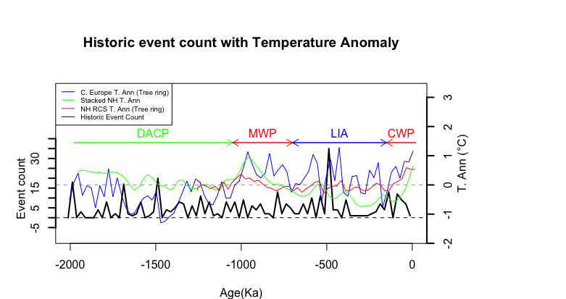

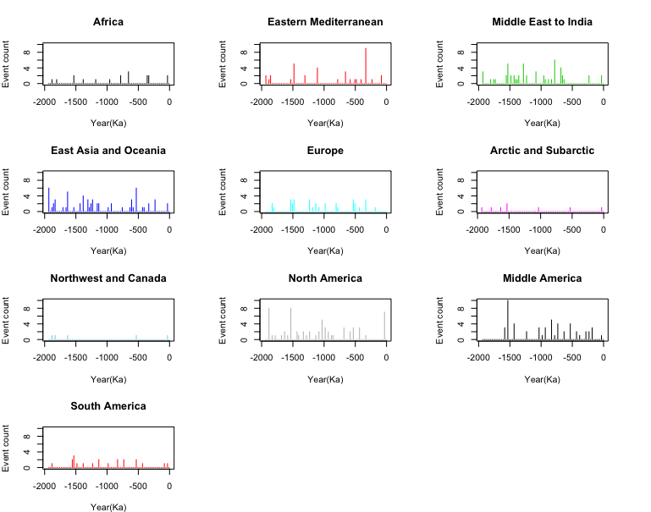

**References:**

1. Zhang, D. D. *et al.* The causality analysis of climate change and large-scale human crisis. *Proc. Natl. Acad. Sci.* **108,** 17296–17301 (2011).
2. B. Peter and B. Peter (2016), “Cultural Responses to Climate Change during the Late Holocene Linked references are available on JSTOR for this article : Cultural Responses to Climate Change During the Late Holocene,” vol. 292, no. 5517, pp. 667–673, 2016.
3. Zheng, J. *et al.* How climate change impacted the collapse of the Ming dynasty. *Clim. Change* **127,** 169–182 (2014).
4. Ge, Q., Hao, Z., Zheng, J. & Shao, X. Temperature changes over the past 2000 yr in China and comparison with the Northern Hemisphere. *Clim. Past* **9,** 1153–1160 (2013).
5. Zhang, D. D. *et al.* The pulse of imperial China: A quantitative analysis of long-term geopolitical and climatic cycles. *Glob. Ecol. Biogeogr.* **24,** 87–96 (2015).
6. DeEr, Z., Hong-Chun, L., Teh-Lung, K. & LongHua, L. On linking climate to Chinese dynastic change: Spatial and temporal variations of monsoonal rain. **55,** 77–83 (2010).
7. Lee, H. F. *et al.* Climate change and epidemics in Chinese history: A multi-scalar analysis. *Soc. Sci. Med.* **174,** 53–63 (2017).
8. Mauri, A., Davis, B. A. S., Collins, P. M. & Kaplan, J. O. The climate of Europe during the Holocene: A gridded pollen-based reconstruction and its multi-proxy evaluation. *Quat. Sci. Rev.* **112,** 109–127 (2015).
9. Gerald H. Haug et al, Climate and the Collapse of Maya Civilization. *Ethnohistory* **42,** 164 (1995).
10. Cullen, H. M. *et al.* Climate change and the collapse of the Akkadian empire: evidence from the deep sea. Geology 28, 379 Á / 82. *Geology;* **28,** 379–382 (2000).
11. Holocene climate and cultural evolution in late prehistoric–early historic West Asia. *Quat. Res.* **66,** 372–387 (2006).
12. Saarni, S., Muschitiello, F., Weege, S., Brauer, A. & Saarinen, T. A late Holocene record of solar-forced atmospheric blocking variability over Northern Europe inferred from varved lake sediments of Lake Kuninkaisenlampi. *Quat. Sci. Rev.* **154,** 100–110 (2016).
13. Hsiang, S. Climate Econometrics. (2016). doi:10.1146/annurev-resource-100815-095343
14. Buhaug, H., Benjaminsen, T. A. & Sjaastad, E. Environmental changes and violent conflict. *Environ. Res. Lett* **7,** 15601 (2012).
15. Koubi, V., Bernauer, T., Kalbhenn, A. & Spilker, G. Climate variability, economic growth, and civil conflict. doi:10.1177/0022343311427173
16. Buhaug, Halvard (2010) Climate not to blame for African civil wars. PNAS 106(49): 20670–20674.
17. Buhaug, H., Benjaminsen, T. A. & Sjaastad, E. Environmental changes and violent conflict. *Environ. Res. Lett* **7,** 15601 (2012).
18. Buhaug, Halvard; Åshild Falch&Nils Petter Gleditsch (2010) The bottom billion and climate change. Paper presented to the 51st Annual Convention of the International Studies Association, New Orleans, LA, 17–20 February.
19. Buhaug, Halvard; Nils Petter Gleditsch & Ole Magnus Theisen (2010) Implications of climate change for armed conflict. In: Robin Mearns & Andy Norton (eds) *Social*

*Dimensions of Climate Change: Equity and Vulnerability in a Warming World*. New Frontiers of Social Policy. Washing- ton, DC: World Bank, 75–101.

1. Burke, Marshall B; Edward Miguel, Shanker Satyanath, John A Dykema & David B Lobell (2009) Warming increases the risk of civil war in Africa. PNAS 106(49): 20670–20674.
2. Chassang, Sylvain & Gerard Padro-i-Miquel (2010) Eco- nomic shocks and civil war. Quarterly Journal of Political Science 4(3): 211–228.
3. Ciccone, Antonio (2011) Economic shocks and civil conflict: A comment. American Economic Review: Applied Economics 3(4): 215–227.
4. Deschenes, Oliver & Michael Greenstone (2007) The economic impacts of climate change: Evidence from agricultural output and random fluctuations in weather. American Economic Review 97(2): 354–385.
5. Devitt, Conor & Richard S J Tol (2012) Civil war, climate change, and development: A scenario study for sub-Saharan Africa. Journal of Peace Research 49(1): 129–145.
6. Garfinkel, Michelle R & Stergios Skaperdas (2007) Economics of conflict: An overview. In: Todd Sandler & Keith Hartley (eds) Handbook of Defense Economics. Amsterdam: Elsevier Science, 649–710.
7. Gleditsch, Nils Petter (1998) Armed conflict and the environment: A critique of the literature. Journal of Peace Research 35(3): 363–380.
8. Hegre, Håvard & Nicholas Sambanis (2006) Sensitivity analysis of the empirical literature on civil war onset. Jour- nal of Conflict Resolution 50(4): 508–535.
9. Hendrix, Cullen & Idean Salehyan (2012) Climate change, rainfall, and social conflict in Africa. Journal of Peace Research 49(1): 35–50.
10. Homer-Dixon, Thomas F (1999) Environment, Scarcity, Violence. Princeton, NJ: Princeton University Press.
11. IPCC (2001) Climate Change 2001: Synthesis Report. Third Assessment Report (AR3) (http://www.grida.no/publica- tions/other/ipcc\_tar/).
12. IPCC (2007) Climate Change 2007: Synthesis Report. Fourth Assessment Report (AR4) (http://www.ipcc.ch/publications\_ and\_data/publications\_ipcc\_fourth\_assessment\_report\_ synthesis\_report.htm).
13. IPCC (2010) Statement on the melting of Himalayan glaciers (http://www.ipcc-wg2.gov/publications/AR4/himalaya-s- tatement-20january2010.pdf).
14. Obama II, Barack Hussein (2009) Climate change speech at the UN General Assembly, 23 September (http://www.nytimes. com/2009/09/23/us/politics/23obama.text.html).
15. Salehyan, Idean (2008) From climate change to conflict? No consensus yet. Journal of Peace Research 45(3): 315–326.
16. Sambanis, Nicholas (2001) Do ethnic and nonethnic civil wars have the same causes? A theoretical and empirical inquiry (Part 1). Journal of Conflict Resolution 45(3): 259–282.
17. WBGU (2008) Climate Change as a Security Risk. London: Earthscan.
18. Zhang, David D; Peter Brecke, Harry F Lee, Yuan-Qing He& Jane Zhang (2007) Global climate change, war, and popu- lation decline in recent human history. PNAS 104(49): 19214–19219.
19. Theisen, O. M., Gleditsch, N. P. & Buhaug, H. Is climate change a driver of armed conflict? *Climatic Change* **117,** 613–625 (2013).

**Materials and methods**

Fourier spectral analysis

Periodogram,

Multitaper analysis

Evolutive harmonic analysis

--- > Significant periodicity, cyclicity

Correlation

Causality

Granger causality, convergent cross mapping, vector autoregression

**Data**:

Frequency of Events in the last 2000 years.

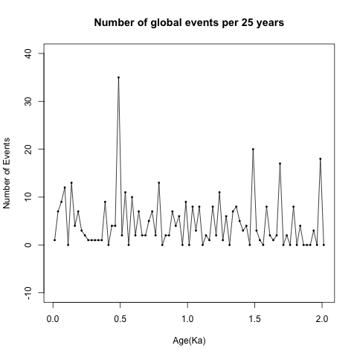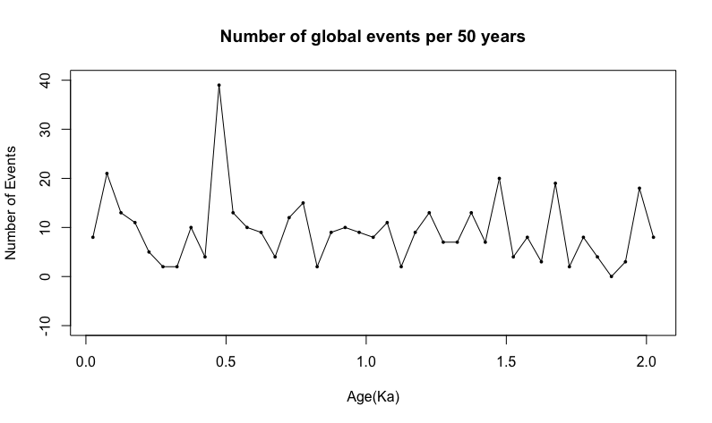

Frequency of Events in the last 5000 years and then for the whole Holocene epoch. But events are clustered in the nearest thousands like (3Ka, 4Ka, 5Ka) which are misleading.

Analysis on the event frequency data from last 2000 years.

Data Processing: Convert the non-stationary event number time series to a weak stationary time series(mean and autocovariance does not change with time) to further do cycle analysis.

1. Demean
2. Filtering with Hanning moving average
3. Detrending (residuals from linear regression)
4. Tapering
5. Hanning smoothing of power spectra

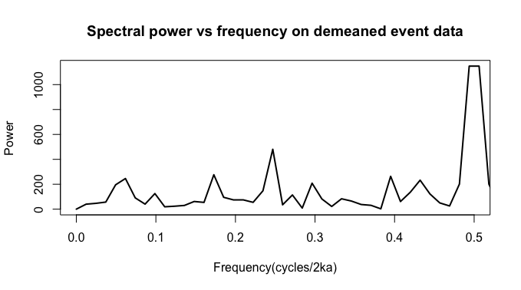

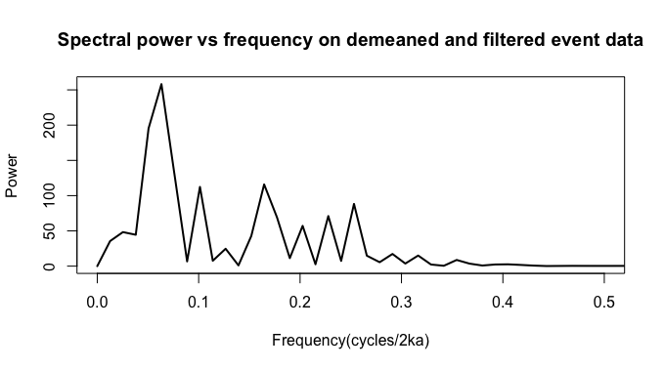

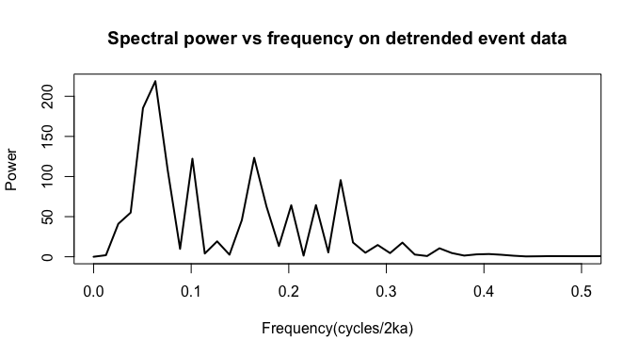

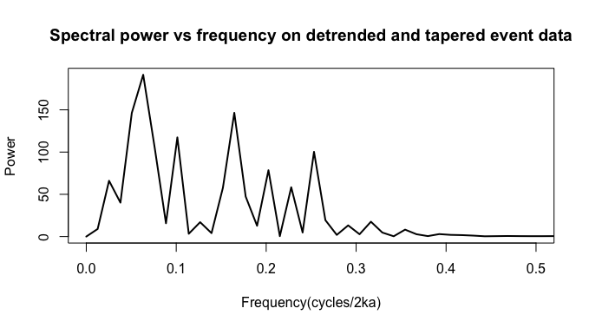

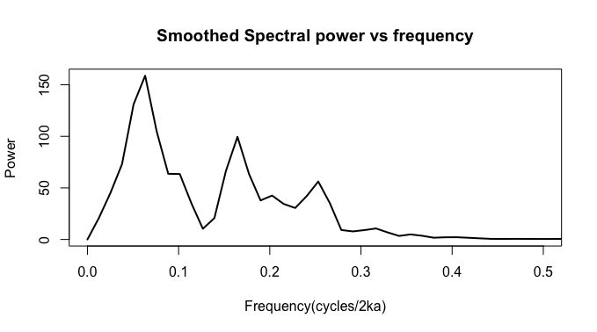

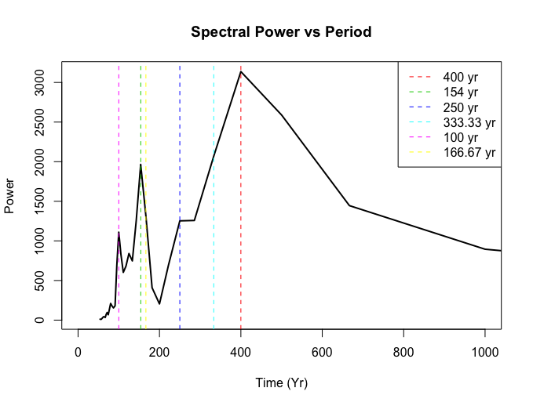

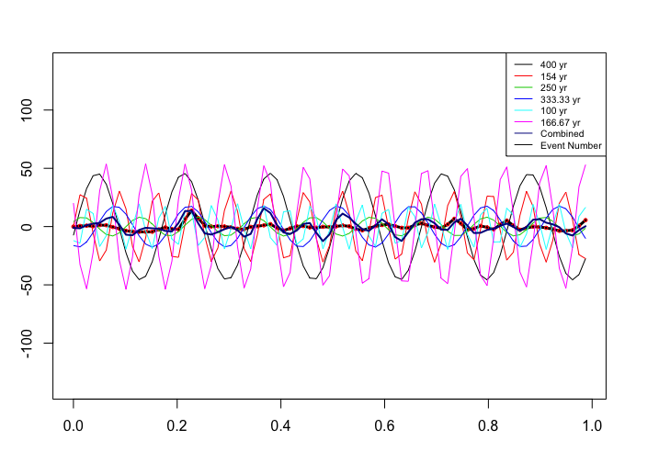

|  |  |  |  |  |
| --- | --- | --- | --- | --- |
| **# Cycles** | **Frequency** | **Period** | **Amplitude** | **Power** |
| 6 | 0.06329114 | 400.0000 | 122.99625 | 158.83075 |
| 14 | 0.16455696 | 153.8462 | 107.57012 | 99.50760 |
| 5 | 0.05063291 | 500.0000 | 107.54739 | 131.11470 |
| 9 | 0.10126582 | 250.0000 | 96.29151 | 63.44699 |
| 7 | 0.07594937 | 333.3333 | 91.47636 | 104.76960 |
| 21 | 0.25316456 | 100.0000 | 89.00611 | 56.19316 |
| 17 | 0.20253165 | 125.0000 | 78.75561 | 42.57242 |
| 3 | 0.02531646 | 1000.0000 | 72.24159 | 45.31505 |
| 19 | 0.22784810 | 111.1111 | 67.90576 | 30.50830 |
| 13 | 0.15189873 | 166.6667 | 67.54380 | 66.50646 |

The top 10 frequency and periods shown in the event frequency data.

|  |  |  |  |
| --- | --- | --- | --- |
| **# Cycles** | **Frequency** | **Power** | **Period** |
| 5 | 0.0625 | 45.40252 | 405.0633 |
| 4 | 0.05 | 35.09184 | 506.3291 |
| 14 | 0.175 | 31.08893 | 144.6655 |
| 8 | 0.1 | 29.57111 | 253.1646 |
| 20 | 0.25 | 27.1028 | 101.2658 |
| 6 | 0.075 | 24.99689 | 337.5527 |
| 2 | 0.025 | 21.18668 | 1012.6582 |
| 18 | 0.225 | 19.44715 | 112.5176 |
| 13 | 0.1625 | 17.98304 | 155.7936 |
| 12 | 0.15 | 12.357 | 168.7764 |

Using periodogram of R (spec.pgram) gives pretty close answer. Power values are different due to normalization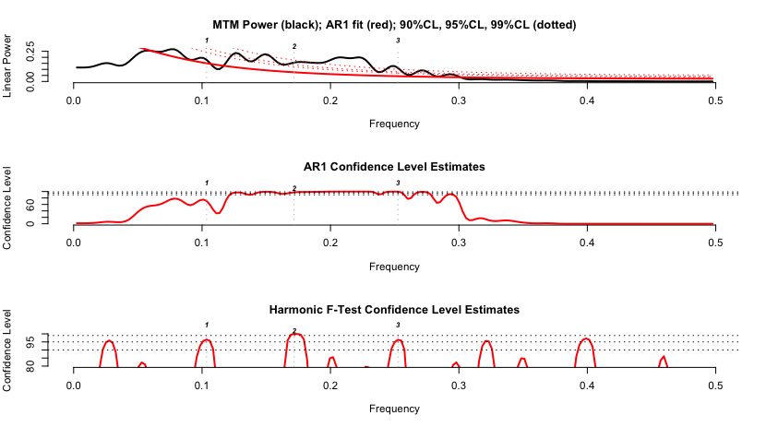

Frequency Harmonic\_CL period

2 0.0625000 0.9803090 405.0633

4 0.1679688 0.9899981 150.7212

5 0.2500000 0.9685964 101.2658

Evolutive Harmonic Analysis



Northern Hemisphere Temperature Data

Christiansen and Ljungqvist [52]: stack of different temperature proxies [°C], extracted from 91 single records, ~30% of them covering the total period, 0 to 1973 AD, 1 year time resolution, northern hemisphere.

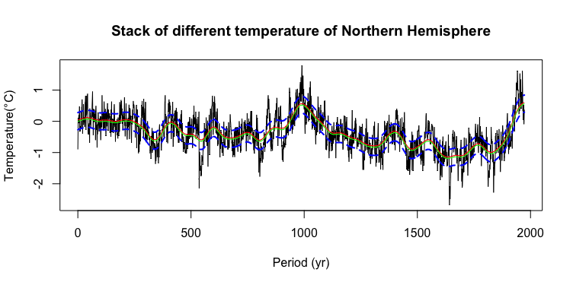

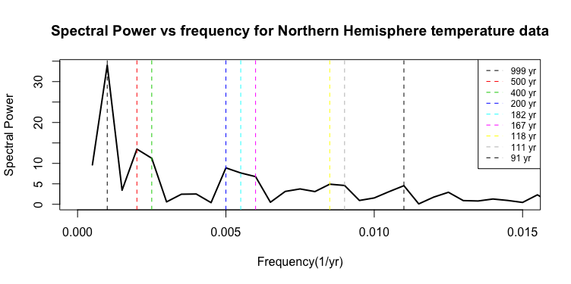

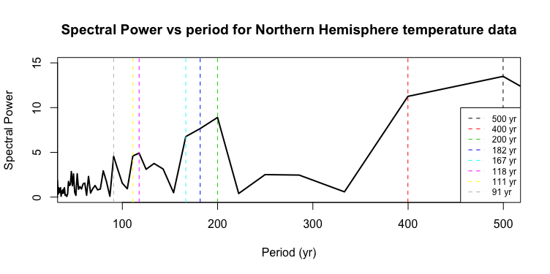

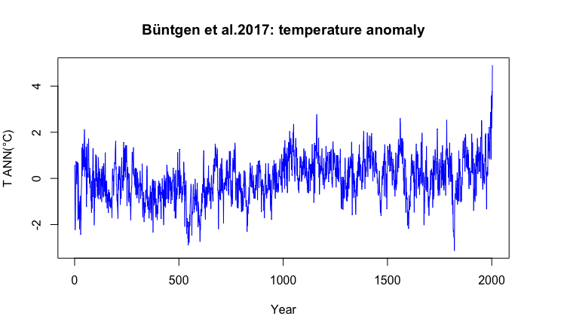

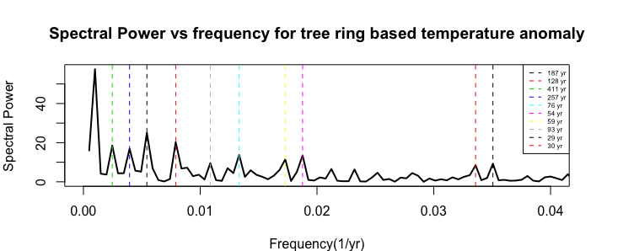

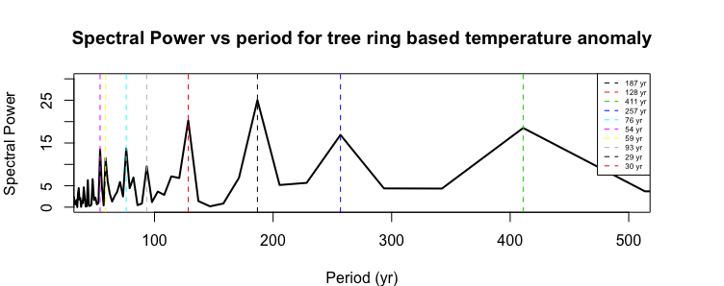

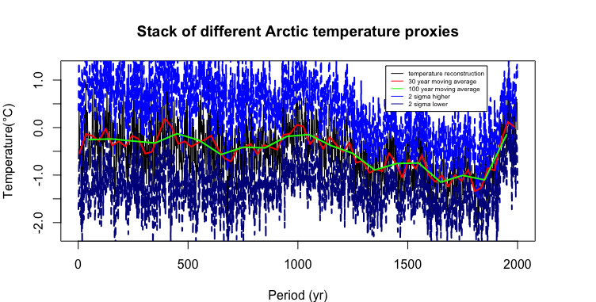

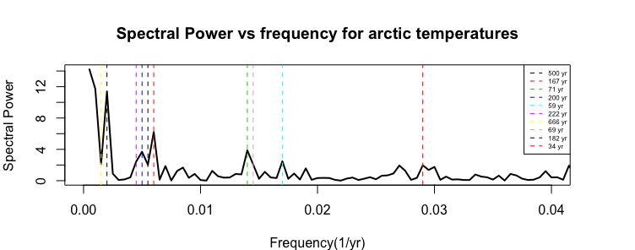

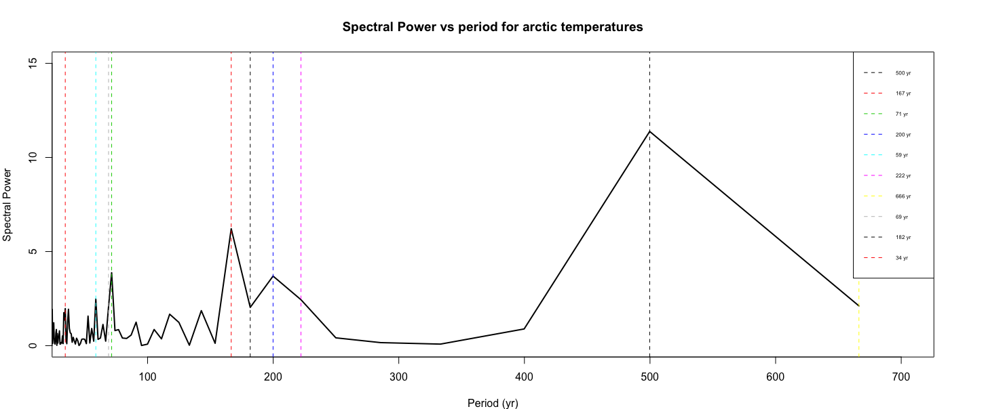

Events in Africa during last 2 thousand years.



Events in the region of East Asia and Oceania during last 2 thousand years.

tscreator_output/Global_event_numbers_50_yr_bin_East_Asia_Oceania_from_0_to2ka.pdf

Events in Middle eastern and Indian region during last 2 thousand years. However, the Indian region events are missing many details of the history of Indian subcontinent.

tscreator_output/Global_event_numbers_50_yr_bin_Middle_East_India_from_0_to2ka.pdf

Events in the region of East Asia and Oceania during last 2 thousand years.

**tscreator_output/Global_event_numbers_50_yr_bin_East_Asia_Oceania_from_0_to2ka.pdf**

Events in European region during last 2 thousand years.

tscreator_output/Global_event_numbers_50_yr_bin_Eastern_Mediterranean_from_0_to2ka.pdf

**Left**: Events in Arctic and Sub-arctic regions during last 2 thousand years. **Right**: Events in Northwest and Canada during last 2 thousand years.

tscreator_output/Global_event_numbers_50_yr_bin_Arctic_Subarctic_from_0_to2ka.pdf tscreator_output/Global_event_numbers_50_yr_bin_Northwest_Canada_from_0_to2ka.pdf

Events in North American region during last 2 thousand years.

tscreator_output/Global_event_numbers_50_yr_bin_North_America_from_0_to2ka.pdf

Events in Middle and South American region during last 2 thousand years.

tscreator_output/Global_event_numbers_50_yr_bin_Middle_South_America_from_0_to2ka.pdf

**Reference:**

1. Christiansen B, Ljungqvist FC. The extra-tropical Northern Hemisphere temperature in the last two millennia: reconstructions of low- frequency variability. Clim Past 2012; 8: 765-786. Data available at ftp://ftp.ncdc.noaa.gov/pub/data/paleo/contributions\_by\_author/ christiansen2012/christiansen2012.txt 2017. (last access: April).
2. Büntgen U, Tegel W, Nicolussi K, et al. 2500 years of European climate variability and human susceptibility. Science 2011; 331: 578-582. Data available at ftp://ftp.ncdc.noaa.gov/pub/data/paleo/treering/reconstructions/europe/buentgen2011europe.txt. 2017. (last access: April)
3. McKay NP, Kaufmann DS. An extended Arctic proxy temperature database for the past 2,000 years. Sci Data 2014; 1(140026). Data available at http://ncdc.noaa.gov/paleo/study/16973 2017. (last access: April).
4. Villalba R, Boninsegna JA, Masiokas M, et al. Large-Scale Temperature Changes Across the Southern Andes: 20th -Century Variations in the context of the Past 400 Years. Climatic Change 2003; 59: 177-232. Data available at: ftp://ftp.ncdc.noaa.gov/pub/data/paleo/treering/ reconstructions/southamerica/patagonia-temperature.txt 2017. (last access: April).
5. Kantelhardt JW, Koscielny-Bunde E, Rego HH, Havlin S, Bunde A. Detecting long-range correlations with detrended fluctuation analysis. Physica A 2001; 295: 441-54. [http://dx.doi.org/10.1016/S0378-4371(01)00144-3]